**AMERICAN INTERNATIONAL UNIVERSITY BANGLADESH (AIUB)**

**FACULTY OF SCIENCE & TECHNOLOGY**

Course Title

**INTRODUCTION TO DATABASE (CSC2108)**

**Semester: Fall 2024-25  
Section: [Y]**

**TITLE**

**University Student Management System**

**Supervised By**

Tamanna Zaman Bristy

**Submitted By: Group no: 5**

|  |  |
| --- | --- |
| **Name** | **ID** |
| Maruf Hossain Chowdhury Durlov | 23-54369-3 |
| MD. Zahin Daiyan | 23-53680-3 |
| Sadia Afrin | 23-54097-3 |
| Arpita Tarafdar Arna | 23-54080-3 |

**TABLE OF CONTENTS**

|  |  |  |
| --- | --- | --- |
| **TOPICS** | | **Page no.** |
| **Title Page** | | **1** |
| **Table of Content** | | **2** |
| **1.** | **Introduction** | **3** |
| **2.** | **Case Study** | **4** |
| **3.** | **ER Diagram** | **5** |
| **4.** | **Normalization** | **6-10** |
| **5.** | **Finalization** | **11** |
| **6.** | **Table Creation** | **12-14** |
| **7.** | **Data Insertion** | **15-17** |
| **8.** | **Query Test** | **18-25** |
| **9.** | **DB connection** | **26-44** |
|  |  |  |
|  |  |  |

# **Introduction**

This project aims to develop a **The University** **Student Management System** designed to streamline the management of students, faculty, departments, courses, clubs, and faculty contacts. The system will use relational database tables, which include: student, faculty, course, department, major, and faculty_contact.

**Tools Used**

* **Database**: Oracle SQL for creating and managing relational tables.
* **Programming Languages**: SQL for querying and managing data in the database.

**Vision/Goal**

The goal of this project is to build a comprehensive system that can handle various aspects of a student’s academic life, from course enrollment to faculty and club memberships. By the end of the project, the system will ensure an efficient, accessible way to track and manage student and faculty data.

**Contribution**

This project offers a comprehensive **University Student Management System** that can be used by universities to efficiently manage student data, courses, faculty, and extracurricular activities. It simplifies access to academic information for students, allowing them to track courses, and faculty details. For universities, it streamlines data management, improves decision-making, and ensures scalability to accommodate growing student populations. This system provides a centralized platform, benefiting both students and university staff in managing and organizing educational data efficiently.

**Targeted Users**

* **Targeted Users**: Students, faculty members, administrative staff, and academic departments.

# **Case Study / Scenario**

In a university management system, students enroll in various courses as part of their academic journey. Each student is uniquely identified by a student ID and has attributes such as name, email, and address. A student can enroll in multiple courses, and each course can have many students, establishing a many-to-many relationship. The enrollment process is managed through an Enrollment relationship that connects students and courses. Each course is uniquely defined by a course ID and has attributes like course name, course code, and course credits. Additionally, the university is organized into departments, each identified by a department ID and department name. Faculty members, who are responsible for teaching courses, are identified by a faculty ID, along with details like name, address, and email. Faculty members may teach multiple courses, forming another many-to-many relationship between faculty and courses. This structured database design ensures efficient management of student records within the university.

# **ER Diagram**

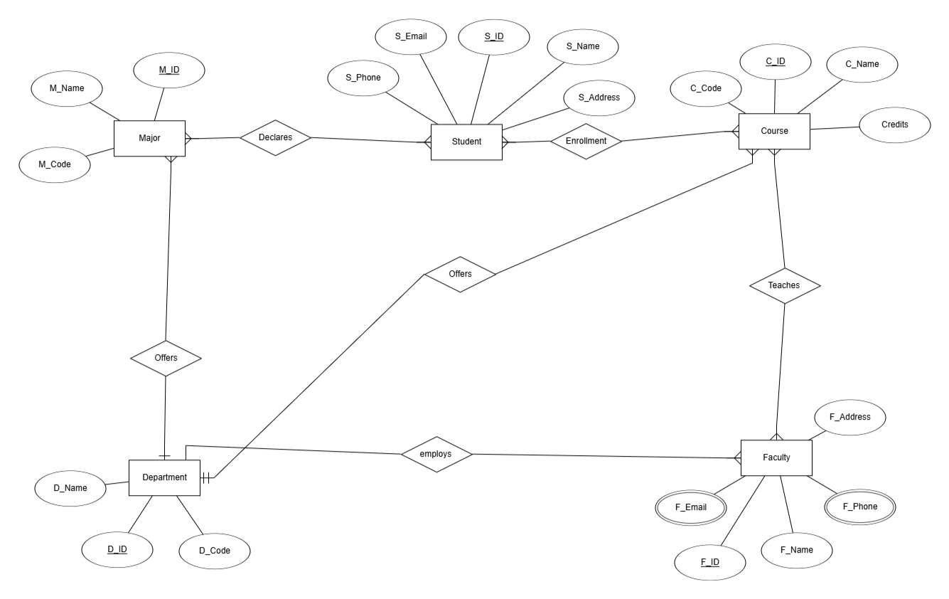

# **Normalization**

Fig-1: ER-Diagram for Student – Major

**Student - Declares - Major**

UNF : M_ID, M_Name, M_code, S_ID, S_Name, S_Email, S_Phone, S_Address

1NF: Multivalued attribute

  S_Phone,S_Email

M_ID, M_Name,M_Code,S_ID,S_Name,S_Address

2NF: 1. M_ID,M_Name,M_Code  
         2. S_ID,S_Name,S_Address,M_ID

         3. S_ID,S_Email,S_Phopne

3NF: Same as 2NF

**Student-Enrollment-Course**

Fig-3: ER-Diagram for Student – Course

UNF : S_ID, S_Name,S_Address,S_Email,S_Phone,C_ID,C_Code,C_Name,C_Credites

1NF: Multivalued attribute  
   S_Phone,S_Email

S_ID,S_Name,S_Address,C_ID,C_Name,C_Code,C_Credits

2NF: 1. S_ID,S_Name,S_Address  
         2. C_ID,C_Name,C_Code,C_Credits,S_ID

         3. S_ID,S_Phone,S_Email,

3NF: Same as 2NF

**Faculty-Teaches-Course**

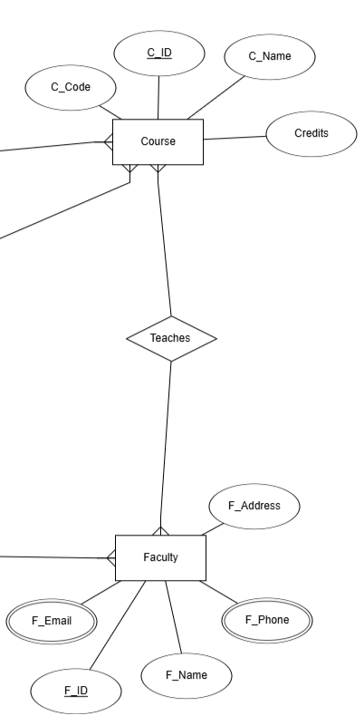

**UNF :**C_ID,C_Code,C_Name,C_Credits,F_ID,F_Email,F_Name,F_Phone,F_Adress

**1NF:** Multivalued attribute

  F_Phone,F_Email

C_ID,C_Name,C_Code,C_Credits,F_ID,F_Name,F_Address

**2NF:** 1. C_ID,C_Name,C_Credits,C_Code  
         2. F_ID,F_Name,F_Address,C_ID

         3. F_ID,F_Email,F_Phone

**3NF:** Same as 2NF

**Depertment-Employes-Faculty**

**UNF :** D_ID,D_Name,D_Code,F_ID,F_Email,F_Name,F_Phone,F_Address

**1NF:** Multivalued attribute

  F_Email,F_Phone

D_ID,D_Name,D_Code, ,F_ID,F_Name,F_Address

**2NF:** 1.D_ID,D_Name,D_Code,  
         2.F_ID,F_Name,F_Address,D_ID

         3.F_ID,F_Email,F_Phone

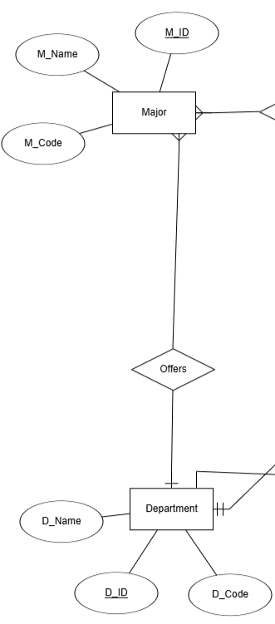**3NF:** Same as 2NF

**Depertment-Offers-Major**

**UNF :** M_ID, M_Name, M_code,D_ID,D_Name,D_Code

**1NF:** M_ID,M_Name,M_Code, D_ID,D_Name,D_Code

**2NF:** 1. M_ID,M_Name,M_Code,D_ID  
         2. D_ID,D_Name,D_Code

**3NF:** Same as 2NF

**Department-Offers-Course**

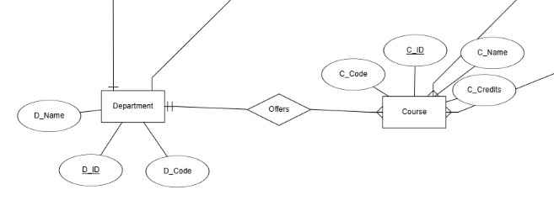

**UNF :** D_ID,D_Name,D_Code,C_ID,C_Name,C_Code,C_Credits

**1NF:** D_ID,D_Name,D_Code,C_ID,C_Name,C_Code,C_Credits

**2NF:** 1. D_ID,D_Name,D_Code  
         2. C_ID,C_Code,C_Name,C_Credits,D_ID

**3NF:** Same as 2NF

# **Finalization**

1. S_ID,S_Name,S_Address,M_ID
2. S_ID,S_Email,S_Phone
3. C_ID,C_Name,C_Code, Credits,S_ID,D_ID
4. D_ID,D_Name,D_Code
5. F_ID,F_Name,F_Address,D_ID,C_ID
6. M_ID,M_Name,M_Code,D_ID
7. F_ID,F_Email,F_Phone

# **Table Creation (DDL Operations)**

|  |  |  |
| --- | --- | --- |
| StudentID1: 23-53680-3 Name: MD. Zahin Diayan | StudentID3: 23-54097-3 Name: Sadia Afrin | |
| StudentID2: 23-54369-3 Name: Maruf Hossain Chowdhury Durlov | StudentID4: 23-54080-3 Name: Arpita Tarafdar Arna | |
| **CO4**: Creating DML, DDL using Oracle and connection with ODBC/JDBC for existing JAVA application | | |
| **PO-e-2:** Use modern engineering and IT tools for prediction and modeling of complex computer science and engineering problem | | Marks |

1. **Student Table Creation** **A screenshot of a computer

   Description automatically generated**
2. **Student Contacts table creation** **A screenshot of a computer

   Description automatically generated**
3. **Department table creation** **A screenshot of a computer

   Description automatically generated**
4. **Course table creation** A screenshot of a computer

   Description automatically generated
5. **Faculty table creation** **A screenshot of a computer

   Description automatically generated**
6. **Faculty contacts table creation** **A screenshot of a computer

   Description automatically generated**
7. **Major table creation** 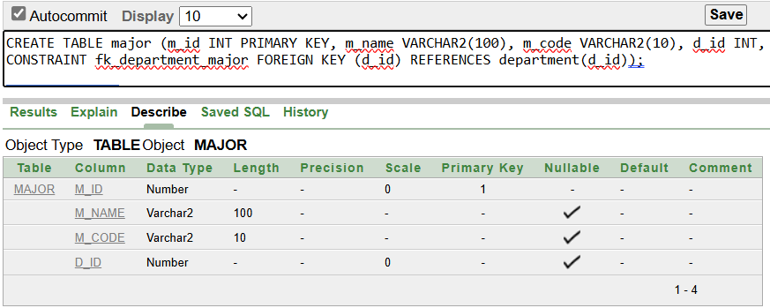

# **Inserted Values in the tables**

## Give the screenshot of all the created tables in Oracle. All the tables should be attached one by one.

Figure: ‘Student’ table

Figure: ‘Student_contact’ table

Figure: Department table

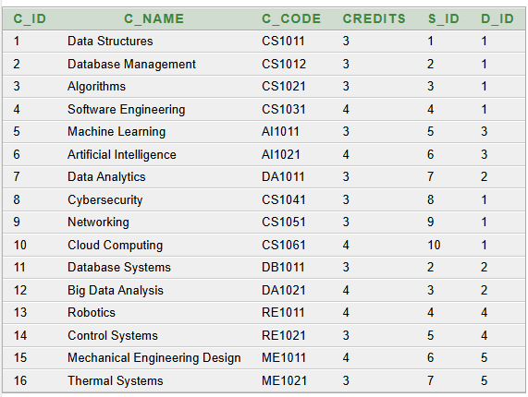

Figure: Course table

Figure: Faculty Table

Figure: Faculty Contact Table

Figure: Major Table

# **Query Test in DB**

1. **Simple query:**

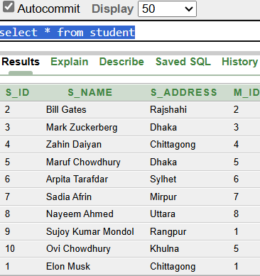

1. **Query with a single row function:**

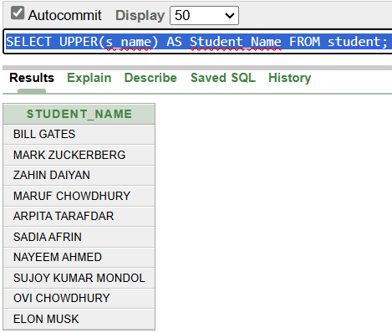

1. **Query with a Multiple row function/ aggregate function:**

1. **2 Single row subquery:**

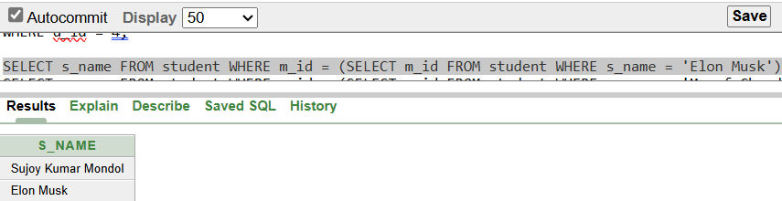

**2 multiple row subquery:**

1. **4 kinds of joining :**

**

**

**Outer join:**

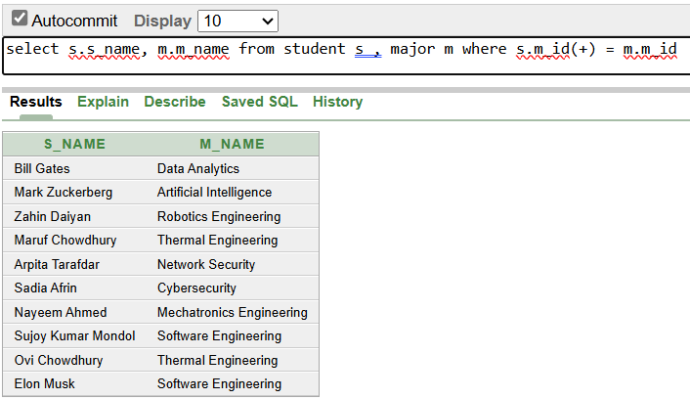

**Self Join:**

1 simple view  
1 complex view

**

Figure: Simple view creation command

Figure: Description of simple view

Figure: Result of the simple view as a whole table

**Complex View:**

Figure: Complex view creation command

Figure: Description of Complex view

Figure: Result of the complex view as a whole table

# **Description of a Successful DB connection**

**Maruf Hossain Chowdhury Durlov [23-54369-3]**

**1**) Acquiring tools: MySQL Java Connector: Obtained the MySQL Java Connector JAR file from the official MySQL website to facilitate Java and MySQL interaction. Additionally, installed XAMPP to access myphp Admin

2) Environment Setup:

• Opened XAMPP, activating both Apache and MySQL services via the control panel.

• Accessed the MySQL admin panel to administer databases.

• Created a database named "The University Management System" and formulated a table named "Student" within it, specifying relevant columns and data types. Filled the table with various values for operations.

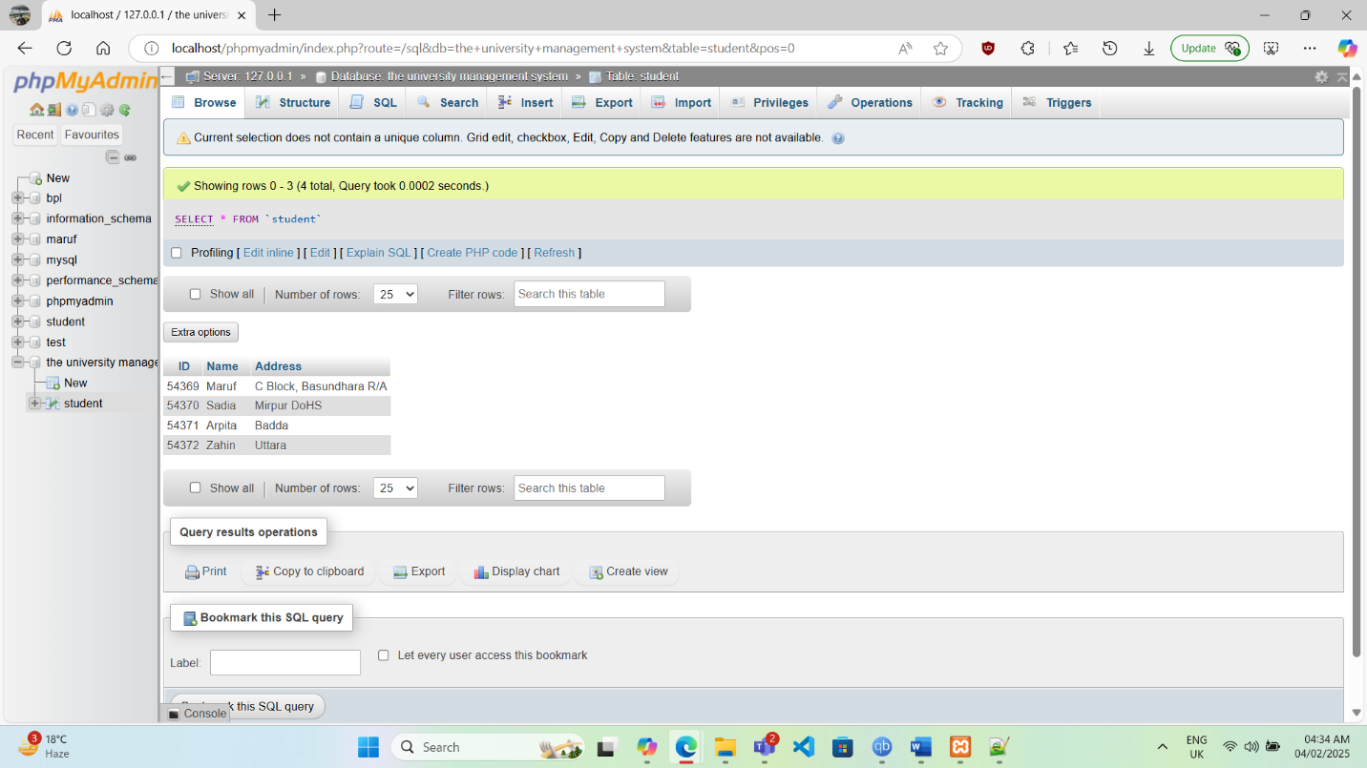

Figure: Screenshot of phpMyAdmin when database and tables are created

3) Java Code :

* Opted for Notepad++ and Java development kit (JDK) as the Integrated Development Environment (IDE) for Java development.
* Then downloaded the DBCODE file from portal and opened the Object.java file.
* Typed the database name after //localhost::3306/ prompt. (at line 9)
* Typed the table name in the st.executeQuery(“select * from student) (at line 14)

* A screenshot of a computer

  Description automatically generatedAfter that opened the containing folder in cmd, compile and execute the following command  
  //javac -cp Driver.jar;. Object.java

//java -cp Driver.jar;. Object

**MD Zahin Daiyan [23-53680-3]**

Steps to Establish Java Connection:

1. At first, I’ve downloaded and installed XAMPP for windows from the official website.

1. Then I downloaded Java Connector fileA screenshot of a computer

   Description automatically generatedA screenshot of a computer

   Description automatically generatedA screenshot of a computer

   Description automatically generated
2. After that I Copied the .jar file to the driver folder and rename the file Driver.jarA screenshot of a computer

   Description automatically generated
3. And I opened XAMPP and start my sql and ApacheA screenshot of a computer

   Description automatically generatedA screenshot of a computer

   Description automatically generated
4. Clicked admin in my sql to go to php’s admin landing pageA screenshot of a computer

   Description automatically generated
5. Made a New Database A screenshot of a computer

   Description automatically generated
6. Entered tables and inserted rows and inserted relevant valuesA screenshot of a computer

   Description automatically generatedA screenshot of a computer

   Description automatically generatedA screenshot of a computer

   Description automatically generated

1. Open the folder where we kept our Driver.jar file and open the object.java file with a text editor
2. Change the Database name to the Same name we created the database with, enter the table name

1. Open containing folders cmd A computer screen with a black screen

   Description automatically generated
2. Complie the java file and exeute it
3. A computer screen with a black screen

   Description automatically generated
4. Connection is Established
5. A computer screen shot of a black screen

   Description automatically generated

**Sadia Afrin [23-54097-3]**

1. First I installed these software and jar file

* Install any IDE
* Download mysql-connector-java-8.0.28.jar
* Install xampp Server

2. I opened xampp server from xampp control panel then start Apache and MySQL module then

open phpMyAdmin by clicking MySQL’s Admin button. There I have created a Database named

‘Database1’ and created a table named ‘myTable’. After that I had inserted some values in it.

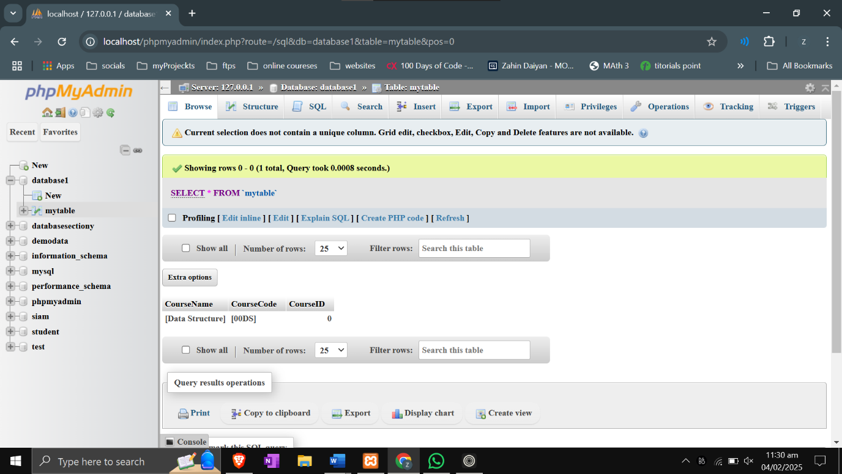

After creating Database and Table, I opened myID(VS Code) and created a

project .In the project I added the mysql-connector-java-8.0.28.jar file in library. After that I

have written java code to connect my Database that I created through xampp. In the IDE

have printed the table

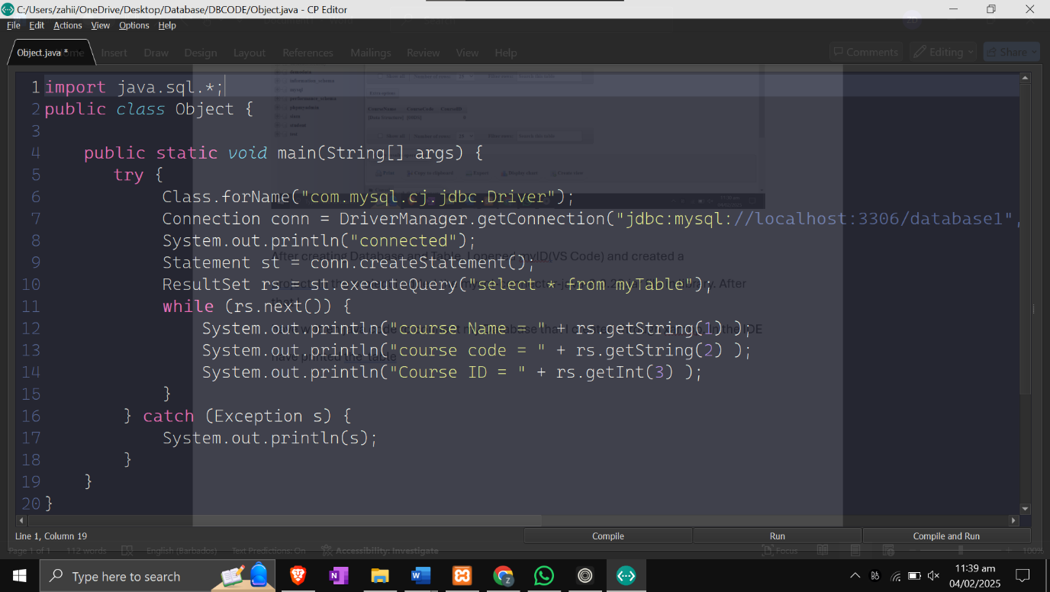

**Arpita Tarafdar Arna [23-54080-3]**

1. First of all, I downloaded the XAMPP software and installed it for creating a local host. After opening XAMPP control panel I started apache and MySql module and clicked on MySql admin for opening the server in a browser and created a database.

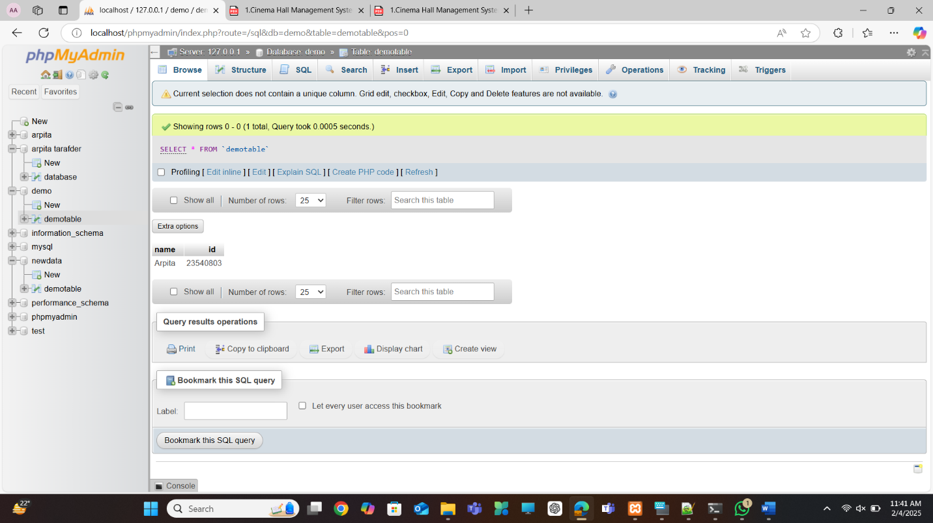

1. After creating a database I installed an IDE. I choose to use notepad++ because I seems easy for me. After installing notepad++ I created a project name university management system and wrote a code for connecting Database with java .

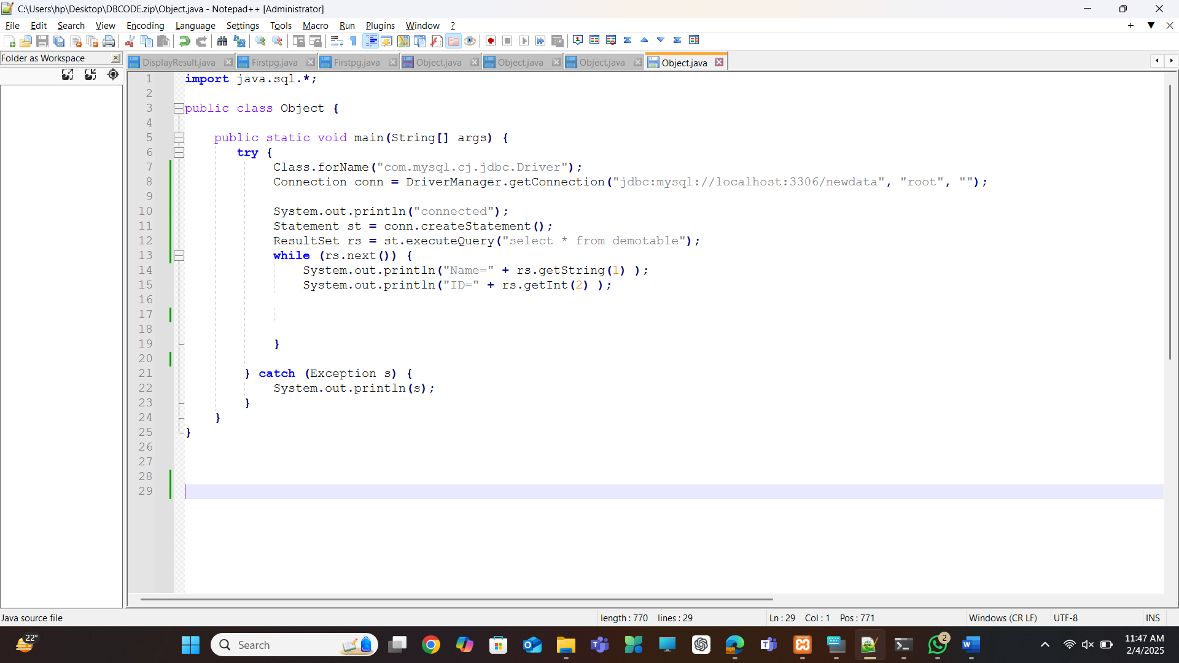

1. Before executing the code I downloaded a java connector JAR file and attached it in the notepad++ referenced library. Then executed the program and it’s connected to the database.

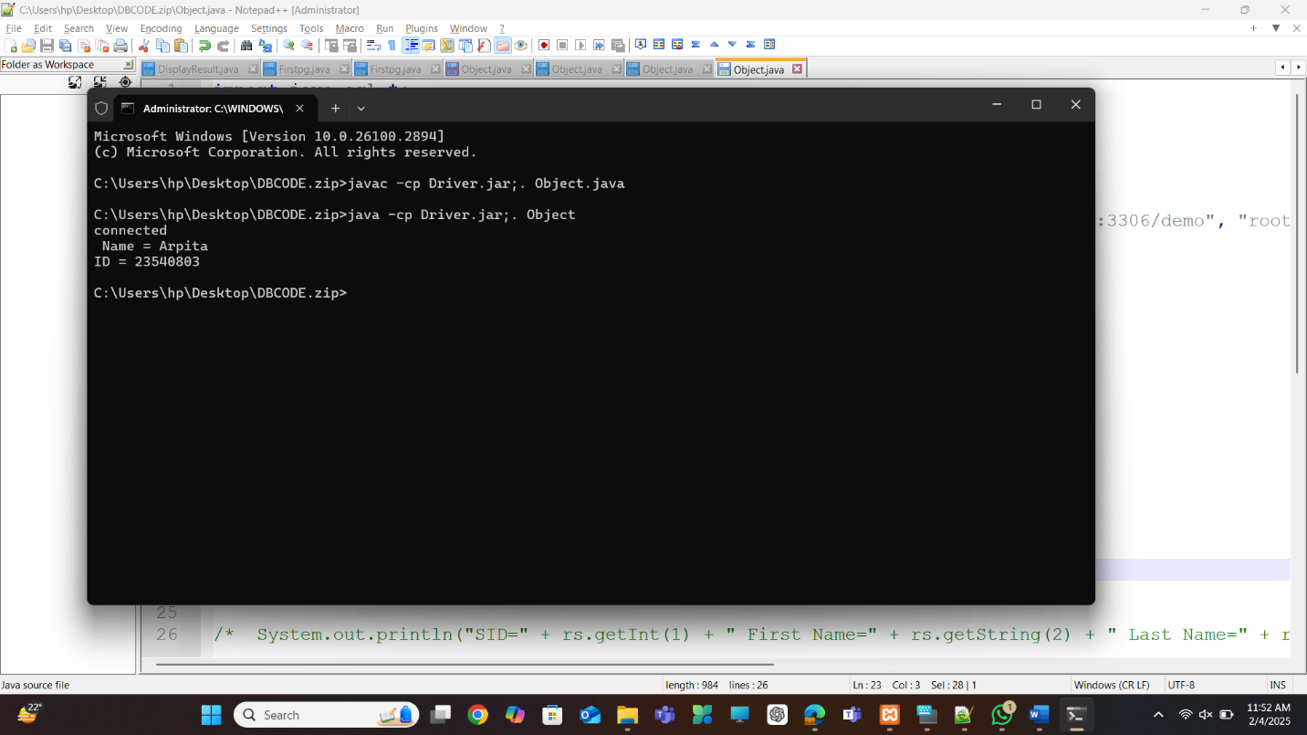

# **Conclusion**

Our University Student Management System helps universities manage student enrollment, courses, and faculty assignments more efficiently using a well-structured database. By applying SQL and normalization, we have ensured accurate data storage, reduced duplication, and automated important tasks. This system benefits students, teachers, and university staff by making academic management smoother.

In the future, we can improve the system by adding a user-friendly interface, cloud storage, and better reporting features. These upgrades will make it even more useful for universities. This project is a step toward modernizing education management, making it more organized and efficient.